

**NIGHT PATROLLING ROBOT**

**A MINI PROJECT REPORT**

***Submitted by***

1. **B. SARAN NIVAS**
2. **BHOOBESH**

**R .INDHU SHRI**

**YOGESH BHANDARI**

***in partial fulfillment for the award of the degree***

***of***

**BACHELOR OF ENGINEERING**

**in**

**MECHATRONICS ENGINEERING**

**SONA COLLEGE OF TECHNOLOGY,**

**SALEM-636005**

NOVEMBER 2021

**BONAFIDE CERTIFICATE**

Certified that this project report **“NIGHT PATROLLING ROBOT”** is the bonafide work of**”R B SARAN NIVAS(1919108035) A BHOOBESH (1919108006) R INDHU SHRI(1919108013) YOGESH BANDARI (1919108049)”**who carried out the project work under my supervision. Certified further that to the best of my knowledge the work reported herein does not form part of any other thesis or dissertation on the basis of which a degree or award was conferred on an earlier occasion on this or any other candidate

|  |  |
| --- | --- |
| **SIGNATURE** | **SIGNATURE** |
| Dr.J.Thiyagarajan | Dr.P.Suresh |
| **SUPERVISOR** | **HEAD OF THE DEPARTMENT** |
| Assistant Professor | Professor |
| Mechatronics Engineering | Mechatronics Engineering |
| Sona College of Technology | Sona College of Technology |

**Submitted for Semester Mini-Project viva-voce examination held on _________**

**INTERNAL EXAMINER**. **EXTERNAL EXAMINER**.

***TABLE OF CONTENTS***

***TITLE* *PAGE NO***

Abstract 1

1. Introduction 2
2. Literature Survey 3
3. System Description 4

3.1 Proposed System 4

3.1.1 Proposed Block Diagram 4

3.2 Power Supply 5

3.2.1 Introduction 5

3.2.2 IC Voltage Regulator 5

3.2.3 Block Diagram 6

3.3 DC Motor 7

3.3.1 Introduction 7

3.3.2 Single Shaft BO motor 7

3.3.3 Advantages of BO motor 8

3.3.4 Motor Driver-H bridge 8

3.3.5 Structure of H bridge 8

3.4 PIR Motion Sensor 9

3.4.1 Introducing the PIR motion sensor 9

3.3.2 Pinout 10

3.4.3 Parts Required 10

3.4.5 Using the PIR sensor in Arduino 12

3.5 ATMEGA Micro Controller 13

3.5.1 Pin diagram 13

3.5.2 Description 14

3.6 Ultra Sonic Sensor 15

3.6.1 Ultrasonic sensor configuration 16

3.6.2 Hc-SC04 Ultrasonic sensor- working 16

3.7 Buzzer 18

3.7.1 General description 18

3.7.2 Pin configuration 19

3.8 Servo Motor 20

3.8.1 Servo mechanics 21

4. Result and Discussion 23

4.1 Circuit Diagram 24

4.2 Experimental Result 25

5. Conclusion 28

5.1 Reference

**ABSTRACT**

Our project based is on IOT. The Internet of Things describes physical object that are embedded with sensors, processing ability, software, and technologies and that connect and exchange data with other devices and system over the internet or other communication networks. Here we used Arduino uno to control the sensors and motors. Arduino uno is an open source micro controller board based on the microchip ATmega328P microcontroller and developed by Arduino.cc. The bot will sense the path using ultra sonic sensor and servo motor. Ultra sonic sensor is an instrument that measures the distance to an object using ultrasonic sound waves. An ultrasonic sensor uses a transducer to send and recieves ultrasonic pules that relay back information about object’s proximity. PIR sensor detect the motion of any unusual activities. PIR sensors allows you to sense motion, almost always used to detect whether a human has moved in or out of the sensor range. It can be operated in both manual and automatic mode through a Arduino remote app using Bluetooth module HC-05. HC-05 Bluetooth module is an easy to use Bluetooth SPP module designed for transparent wireless serial connection setup. when the bot is turned on it will automatically sense the path and guard the parameter and the alert when it sense a human detection.

**CHAPTER-1**

1. **INTRODUCTION**

Robots function as a computer, and can be controlled remotely. Patrolling is nothing more than keeping track of an area where the corresponding robot patrolling area is constantly moving and traveling is continuously moving in the area allocating to the robot. Night vision camera plays a significant role in rendering the robotic device automatic. Robotics is a modern technology which is changing human life, as the key and emerging component of robotics is control and automation

The robot takes the pictures at 360 degree rotation. Then, these images are sent to the user in real time, they will be evaluated by the user and action will be taken if any problems are found. Using camera motor we may gather knowledge from both sides of the external field. We can control the robot in two ways: one wired, and the other wireless. Wireless monitoring helps us operate robot from various locations. GSM is used within this module and MCU is used for camera support node. Any small sound resulting in the alarm and robot will automatically go to the area and capture the area's image and send it to the user. In making an automated robotic device, Raspberry Pi connected to the camera plays an important role. The robotic vehicle travels at different intervals, and is fitted with camera and sound sensors for night vision.

In patrolling it uses a predefined line to follow its direction. Once sound is rotating HD camera to detect any intrusion. It has the capability of tracking sound at the premises. Any sound after company is closed and its predefined direction starts to travel towards the sound. It then scans the region using its camera to detect any known human faces. It captures and starts to relay photographs of the situation immediately upon identification of sound or human face. Here we use IOT gecko to get transmitted images and view them with warning sounds to the user. So we're putting forward a fully autonomous security robot that runs

relentlessly and patrols wide areas alone to protect the building. Robot patrolling is primarily used in the military zone, hospitals, shopping mall, national functions, industrial field, etc.

**CHAPTER 2**

**LITERATURE SURVEY**

The Night Patrolling Robotic vehicle moves in a randompath while watching. The framework utilizes IR based way following framework for watching allocated zone. The development of a robot is additionally controlled consequently through deterrent recognizing sensors to stay away from the crash.**[5]**

The Night Patrolling Robot is fully autonomous having the option of manual override as per requirement of the situation**[6]**

The robot uses basic night vision camera with advanced Zing Bee technology which allows to monitor areas where no internet communication is available and at times when communication collapses due to disaster**[7]**

The difference between the two ideas is the robot used in the paper mentioned, uses Infrared Sensor instead of Ultrasound Sensors for the obstacle avoidance and uses Wi-Fi instead of GSM, making it short ranged**[8]**

A new approach to autonomously detect and track a moving object in a video captured by a moving camera (possibly mounted on a unmanned vehicle, UxV) is proposed in this paper.**[9]**

They introduce a new security method in the study to protect women during unusual behavaiours using the Raspberry Pi**[10]**

**CHAPTER 3**

**SYSTEM DESCRIPTION**

* 1. **PROPOSED SYSTEM**

In this project, we propose a security patrolling robot manages the utilization of ARDUINO UNO to survey night patrolling in an area. These days’ video reconnaissance significant as far as security. Top of the line cameras are required in business spaces, schools and clinics, stockrooms, and outside conditions. The robotic vehicle moves at specific intervals and outfits with night vision camera and sound sensors. It stops at specific points and moves to next points if sound is identified. It can screen sound in the premises. Any sound after working hours and it starts towards the sound on its predefined way. It scans the region utilizing its camera to detect any human appearances distinguished. It captures and starts transmitting the pictures of circumstance quickly on sound or human face identification.

* + 1. **PROPOSED BLOCK DIAGRAM**

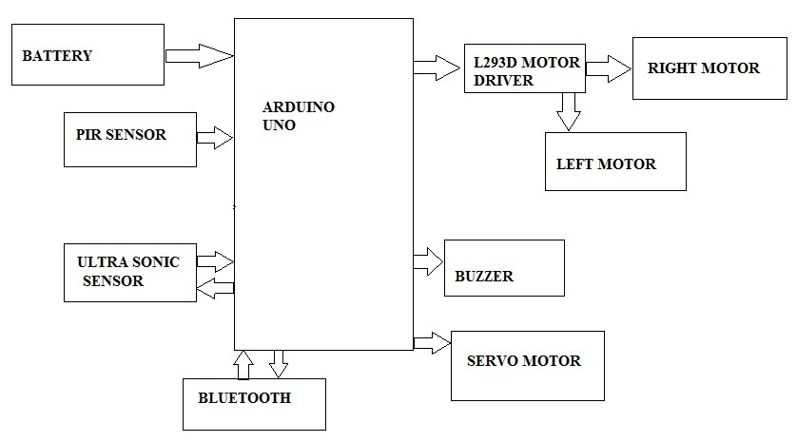

**FIG 3.1 Proposed Block Diagram**

* 1. **POWER SUPPLY**
     1. **INTRODUCTION**

The present chapter introduces the operation of power supply circuits built using filters, rectifiers, and then voltage regulators. Starting with an AC voltage, a steady DC voltage is obtained by rectifying the AC voltage, then filtering to a DC level, and finally, regulating to obtain a desired fixed DC voltage. The regulation is usually obtained from an IC voltage regulator unit, which takes a DC voltage and provides a somewhat lower DC voltage, which remains the same even if the input DC voltage varies, or the output load connected to the DC voltage changes.

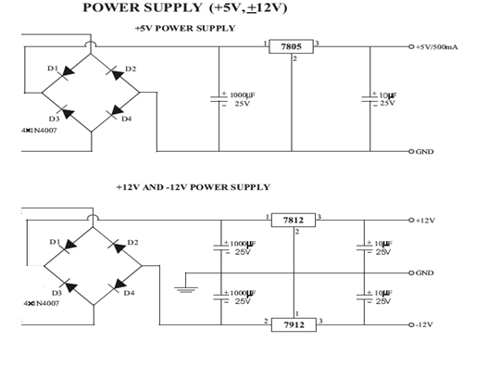

**Fig3.2:Circuit Diagrams for Power Supply**

**3.2.2 IC VOLTAGE REGULATORS**

Voltage regulators comprise a class of widely used ICs. Regulator IC units contain the circuitry for reference source, comparator amplifier, control device, and overload protection all in a single IC. Although the internal construction of the IC is somewhat different from that described for discrete voltage regulator circuits, the external operation is much the same. IC units provide regulation of either a fixed positive voltage, a fixed negative voltage, or an adjustable set voltage.A power supply can be built using a transformer connected to the AC

supply line to step the AC voltage to desired amplitude, then rectifying that AC voltage, filtering with a capacitor and RC filter, if desired, and finally regulating the DC voltage using an IC regulator. The regulators can be selected for operation with load currents from hundreds of Milli amperes to tens of amperes, corresponding to power ratings from milliwatts to tens of watts

**3.2.3**  **BLOCK DIAGRAM**

The AC voltage, typically 220V RMS, is connected to a transformer, which steps that AC voltage down to the level of the desired DC output. A diode rectifier then provides a full-wave rectified voltage that is initially filtered by a simple capacitor filter to produce a DC voltage. This resulting DC voltage usually has some ripple or AC voltage variation.

A regulator circuit removes the ripples and also remains the same DC value even if the input DC voltage varies, or the load connected to the output DC voltage changes. This voltage regulation is usually obtained using one of the popular voltage regulator IC units.

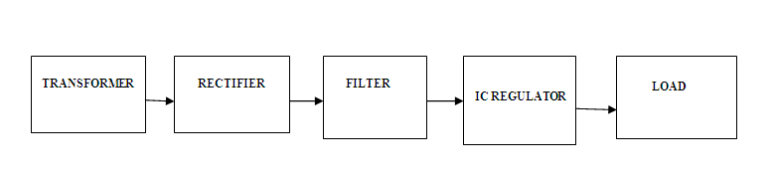

**Fig3.3:Block Diagram of Power Supply**

**3.****3 DC MOTOR**

**3.3.1 INTRODUCTION**

Almost every mechanical movement that we see around us is accomplished by an electric motor. Electric machines are a means of converting energy. Motors take electrical energy and produce mechanical energy. Electric motors are used to power hundreds of devices we use in everyday life. Motors come in various sizes. Huge motors that can take loads of 1000’s of Horsepower are typically used in the industry. Some examples of large motor applications include elevators, electric trains, hoists, and heavy metal rolling mills. Examples of small motor applications include motors used in automobiles, robots, hand power tools and food blenders. Micro-machines are electric machines with parts the size of red blood cells, and find many applications in medicine. Electric motors are broadly classified into two different categories: DC (Direct Current) and AC (Alternating Current). Within these categories are numerous types, each offering unique abilities that suit them well for specific applications. In most cases, regardless of type, electric motors consist of a stator (stationary field) and a rotor (the rotating field or armature) and operate through the interaction of magnetic flux and electric current to produce rotational speed and torque. DC

motors are distinguished by their ability to operate from direct current. There are different kinds of D.C. motors, but they all work on the same principles. In this chapter, we will study their basic principle of operation and their characteristics. It’s important to understand motor characteristics so we can choose the right one for our application requirement.

**3.3.2 SINGLE SHAFT BO MOTOR**

The 150 RPM Single Shaft BO Motor - Straight motor gives good torque and rpm at lower operating voltages, which is the biggest advantage of these motors.

Small shaft with matching wheels gives an optimized design for your application or robot. Mounting holes on the body & light weight makes it suitable for in-circuit placement. This motor can be used with 69mm Diameter Wheel for Plastic Gear Motors.

It is an alternative to our metal gear DC motors. It comes with an operating voltage of 3-12V and is perfect for building small and medium robots.

The motor is ideal for DIY enthusiasts. This motor set is inexpensive, small, easy to install, and ideally suited for use in a mobile robot car. They are commonly used in our 2WD platforms.

**3.3.3** **ADVANTAGES OF BO MOTOR**

* Cost-effectiveness of the injection-molding process.
* Elimination of machining operations.
* Low density: lightweight, low inertia.
* Uniformity of parts.
* Capability to absorb shock and vibration as a result of elastic compliance.
* Ability to operate with minimum or no lubrication, due to inherent lubricity.
* The relatively low coefficient of friction.

**3.3.4 MOTOR DRIVER –H BRIDGE**

H Bridge is an electronic circuit that enables a voltage to be applied across a load in either direction. These circuits are often used in robotics and other applications to allow DC motors to run forwards and backwards. H bridges are available as integrated circuits, or can be built from discrete components.

**3.3.5 STRUCTURE OF H-BRIDGE**

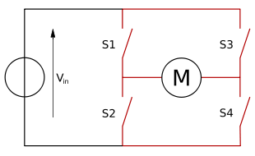

**FIG 3.3 Circuit of H bridge**

The term H bridge is derived from the typical graphical representation of such a circuit. An H bridge is built with four switches (solid-state or mechanical). When the switches S1 and S4 (according to the first figure) are closed (and S2 and S3 are open) a positive voltage will be applied across the motor. By opening S1 and S4 switches and closing S2 and S3 switches, this voltage is reversed, allowing reverse operation of the motor. Using the nomenclature above, the switches S1 and S2 should never be closed at the same time, as this would cause a short circuit on the input voltage source. The same applies to the switches S3 and S4. This condition is known as shoot-through

**3.4 PIR MOTION SENSOR**

The output of **PIR motion** detection **sensor** can be connected directly to one of the **Arduino** (or any microcontroller) digital pins. If any **motion** is detected by the **sensor**, this pin value will be set to “1”. The two potentiometers on the board allow you to adjust the sensitivity and delay time after detecting a movement

**3.4.1 INTRODUCING THE PIR MOTION SENSOR**

The PIR motion sensor is ideal to detect movement. PIR stand for “Passive Infrared”. Basically, the PIR motion sensor measures infrared light from objects in its field of view.

So, it can detect motion based on changes in infrared light in the environment. It is ideal to detect if a human has moved in or out of the sensor range.

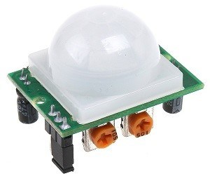

**FIG:3.4 PIR sensor**

The sensor in the figure above has two built-in potentiometers to adjust the delay time (the potentiometer at the left) and the sensitivity (the potentiometer at the right).

**3.4.2 PINOUT**

Wiring the PIR motion sensor to an Arduino is pretty straightforward – the sensor has only 3 pins.

* GND – connect to ground
* OUT – connect to an Arduino digital pin
* 5V – connect to 5V

**3.4.3 PARTS REQUIRED**

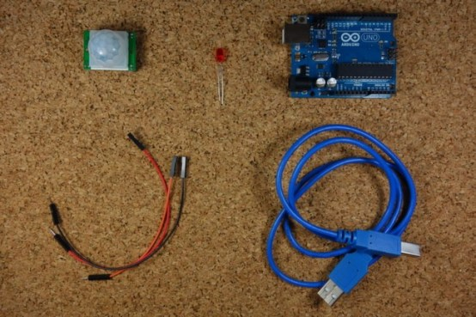

**FIG : 3.5 Parts Used**

Passive Infra Red sensors can detect movement of objects that radiate IR light (like human bodies). Therefore, using these sensors to detect human movement or occupancy in security systems is very common. Initial setup and calibration of these sensors takes about 10 to 60 seconds.

The HC-SR501’s infrared imaging sensor is an efficient, inexpensive and adjustable module for detecting motion in the environment. The small size and physical design of this module allow you to easily use it in your project.

The output of PIR motion detection sensor can be connected directly to one of the Arduino (or any microcontroller) digital pins. If any motion is detected by the sensor, this pin value will be set to “1”. The two potentiometers on the board allow you to adjust the sensitivity and delay time after detecting a movement.

PIR modules have a passive infrared sensor that detects the occupancy and movement from the infrared radiated from human body. You can use this module in security systems, smart lighting systems, automation, etc. There are different PIR modules available in the market, but all of them are basically the same. They all have at least a Vcc pin, GND pin, and digital output. In some of these modules, there is a ball like a lens on the sensor that improves the viewing angle.

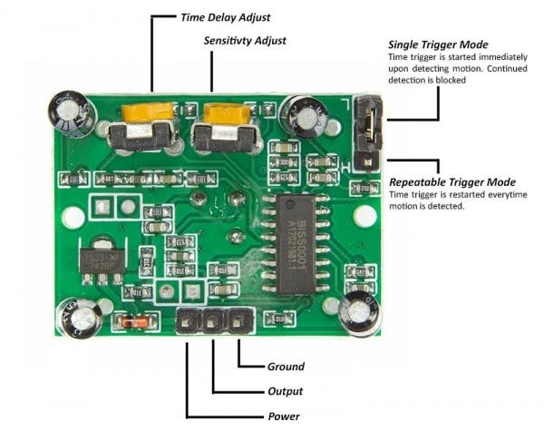

**FIG:3.6 CIRCUIT IN THE PIR SENSOR**

**3.4.5 USING THE PIR SENSOR IN ARDUINO:**

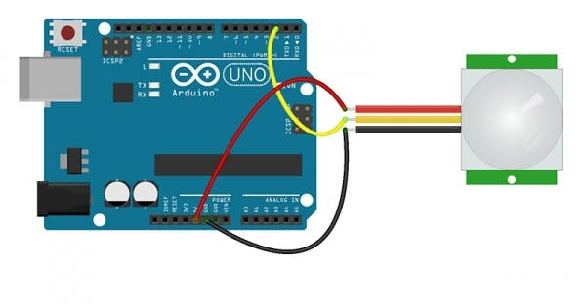**FIG: 3.7** **connect PIR output to any digital pin**.

There is a jumper behind this module. If you move the jumper to L position, the sensor will ‘toggle’ (change state) whenever motion is detected. This is unlikely to be of much use in a practical applications. This mode is called non-triggering or Single Triggering mode.

Moving the jumper to the H position will result in the more usual sensor logic. The sensor will turn on when motion is detected and turn off a while after the last motion is detected. This sensor will reset the timer (which would otherwise turn the output off) each time motion is detected; this would be applicable, for example, for room occupancy lighting control where you don’t want the lights to blink off while the unit resets. This is called Retriggering mode. (or repeatable trigger mode).

There are also two potentiometers behind this module. By changing the SENSITIVITY potentiometer, you can reduce or increase the sensitivity of the sensor (clockwise increase), and also by changing TIME potentiometer the output delay after movement detection will be changed.

**3.5 ATMEGA MICRO CONTROLLER**

**3.5.1 PIN DIAGRAM:**

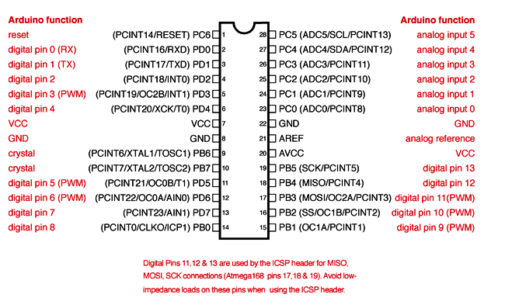

**FIG: 3.8 Pin diagram of ATMEGA**

**Features:**

* High-performance, Low-power AVR, 8-bit Microcontroller
* Advanced RISC Architecture
* Nonvolatile Program and Data Memories
* Two 8-bit Timer/Counters with Separate Prescaler, one Compare Mode
* Byte-oriented Two-wire Serial Interface
* Programmable Serial USART
* Master/Slave SPI Serial Interface
* Programmable Watchdog Timer with Separate On-chip Oscillator
* On-chip Analog Comparator
* Power-on Reset and Programmable Brown-out Detection
* Internal Calibrated RC Oscillator
* External and Internal Interrupt Sources
* I/O and Packages
  + 23 Programmable I/O Lines
  + 28-lead PDIP, 32-lead TQFP, and 32-pad MLF
* Operating Voltages
* 2.7 - 5.5V (ATmega16L)
* 4.5 - 5.5V (ATmega16)
* Speed Grades
* 0 - 8 MHz (ATmega16L)
* 0 - 16 MHz (ATmega16)
  + Power Consumption at 4 Mhz, 3V, 25°C
* Active: 3.6 Ma
* Idle Mode: 1.0 mA
* Power-down Mode: 0.5

**3.5.2 DESCRIPTION:**

The ATmega16 is a low-power CMOS 8-bit microcontroller based on the AVR RISC architecture. By executing powerful instructions in a single clock cycle, the ATmega16 achieves throughputs approaching 1 MIPS per MHz, allowing the system designed to optimize power consumption versus processing speed. The AVR core combines a rich instruction set with 32 general-purpose working registers. All the 32 registers are directly connected to the Arithmetic Logic Unit (ALU), allowing two independent registers to be accessed in one single instruction executed in one clock cycle. The resulting architecture is more code efficient while achieving throughputs up to ten times faster than conventional CISC microcontrollers.

**3.6 ULTRASONIC SENSORS:**

**Ultrasonic sensors work** by emitting sound waves at a frequency too high for humans to hear. They then wait for the sound to be reflected back, calculating distance based on the time required. This is similar to how radar measures the time it takes a radio wave to return after hitting an object

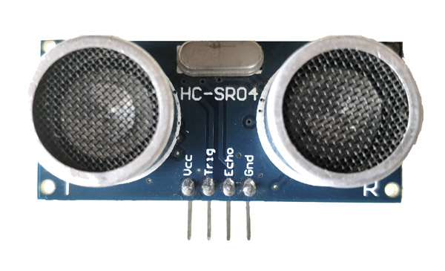**FIG: 3.9 Ultrasonic sensor**

**3.6.1 ULTRASONIC SENSOR CONFIGURATION :**

|  |  |  |
| --- | --- | --- |
| **Pin Number** | **Pin Name** | **Description** |
| 1 | Vcc | The Vcc pin powers the sensor, typically with +5V |
| 2 | Trigger | Trigger pin is an Input pin. This pin has to be kept high for 10us to initialize measurement by sending US wave. |
| 3 | Echo | Echo pin is an Output pin. This pin goes high for a period of time which will be equal to the time taken for the US wave to return back to the sensor. |
| 4 | Ground | This pin is connected to the Ground of the system. |

**TABLE: 3.1 PIN Description**

**HC-SR04 Sensor Features**

* Operating voltage: +5V
* Theoretical  Measuring Distance: 2cm to 450cm
* Practical Measuring Distance: 2cm to 80cm
* Accuracy: 3mm
* Measuring angle covered: <15°
* Operating Current: <15mA
* Operating Frequency: 40Hz

**3.6.2 HC-SR04 ULTRASONIC SENSOR- WORKING:**

As shown above the **HC-SR04 Ultrasonic (US) sensor** is a 4 pin module, whose pin names are Vcc, Trigger, Echo and Ground respectively. This sensor is a very popular sensor used in many applications where measuring distance or sensing objects are required. The module has two eyes like projects in the front which forms the Ultrasonic transmitter and Receiver.

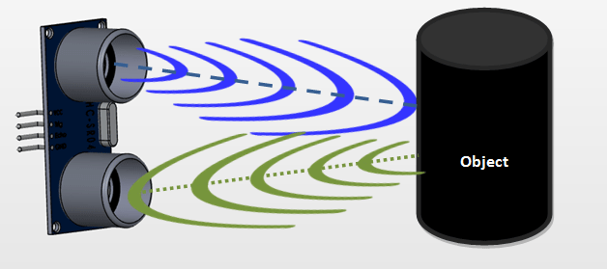

**FIG: 3.10 Working of Ultrasonic sensor**

Ultrasonic sensors work by sending out a sound wave at a frequency above the range of human hearing. The transducer of the sensor acts as a microphone to receive and send the ultrasonic sound. Our ultrasonic sensors, like many others, use a single transducer to send a pulse and to receive the echo**.**

**Applications**

* Used to avoid and detect obstacles with robots like biped robot, obstacle avoider robot, path finding robot etc.
* Used to measure the distance within a wide range of 2cm to 400cm
* Can be used to map the objects surrounding the sensor by rotating it
* Depth of certain places like wells, pits etc can be measured since the waves can penetrate through water

**3.7 BUZZER**

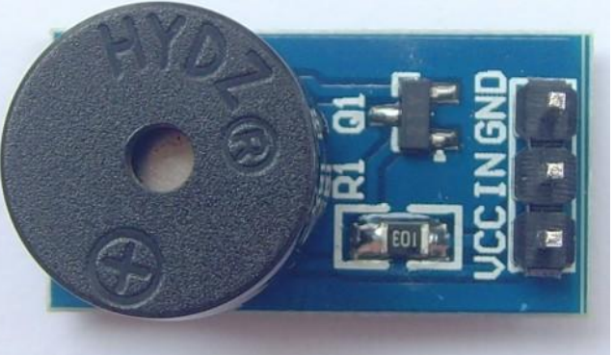

**FIG: 3.11 Buzzer**

**3.7.1 General Description:**

A buzzer or beeper is an audio signaling device, which may be mechanical, electromechanical, or piezoelectric. Typical uses of buzzers and beepers include alarm devices, timers and confirmation of user input such as a mouse click or keystroke.

Buzzer is an integrated structure of electronic transducers, DC power supply,widely used in computers, printers, copiers, alarms, electronic toys, automotiveelectronic equipment, telephones, timers and other electronic products for sounddevices. Active buzzer 5V Rated power can be directly connected to a

continuoussound, this section dedicated sensor expansion module and the board in combination,can complete a simple circuit design, to "plug and play."

**Specifications:**

• On-board passive buzzer

• On-board 8550 triode drive

• Can control with single-chip microcontroller IO directly

• Working voltage: 5V

• Board size: 22 (mm) x12 (mm)

**3.7.2 PIN CONFIGURATION:**

1. VCC

2. Input

3. Ground

Schematic Diagram:

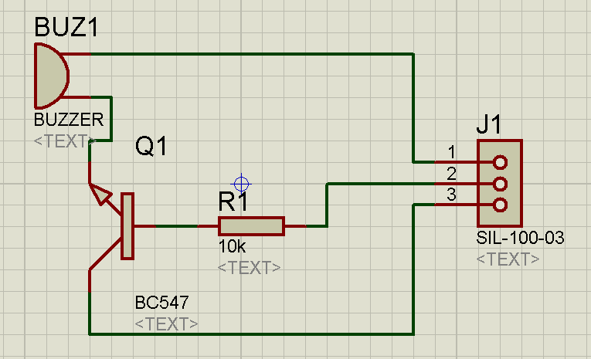

**FIG: 3.12 Buzzer Pin configuration**

**3.8** [**SERVO MOTOR:**](https://circuitdigest.com/article/servo-motor-basics)

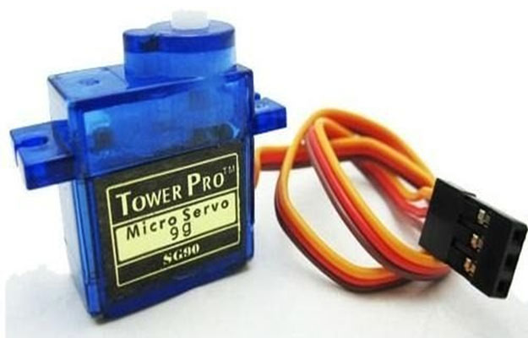

**FIG:3.13 Servo Motor**

A **servo motor** is an electrical device which can push or rotate an object with great precision. If you want to rotate and object at some specific angles or distance, then you use servo motor. It is just made up of simple motor which run through **servo mechanism**. If motor is used is DC powered then it is called DC servo motor, and if it is AC powered motor then it is called AC servo motor. We can get a very high torque servo motor in a small and light weight packages. Doe to these features they are being used in many applications like toy car, RC helicopters and planes, Robotics, Machine etc.

Servo motors are rated in kg/cm (kilogram per centimeter) most hobby servo motors are rated at 3kg/cm or 6kg/cm or 12kg/cm. This kg/cm tells you how much weight your servo motor can lift at a particular distance. For example: A 6kg/cm Servo motor should be able to lift 6kg if the load is suspended 1cm away from the motors shaft, the greater the distance the lesser the weight carrying capacity.

The position of a servo motor is decided by electrical pulse and its circuitry is placed beside the motor.

**3.8.1 SERVO MECHAN:**

**It consists of three parts:**

1. Controlled device
2. Output sensor
3. Feedback system

It is a closed loop system where it uses positive feedback system to control motion and final position of the shaft. Here the device is controlled by a feedback signal generated by comparing output signal and reference input signal.

Here reference input signal is compared to reference output signal and the third signal is produces by feedback system. And this third signal acts as input signal to control device. This signal is present as long as feedback signal is generated or there is difference between reference input signal and reference output signal. So the main task of servomechanism is to maintain output of a system at desired value at presence of noises..

**Controlling Servo Motor:**

All motors have three wires coming out of them. Out of which two will be used for Supply (positive and negative) and one will be used for the signal that is to be sent from the MCU.

Servo motor is controlled by PWM (Pulse with Modulation) which is provided by the control wires. There is a minimum pulse, a maximum pulse and a repetition rate. Servo motor can turn 90 degree from either direction form its neutral position. The servo motor expects to see a pulse every 20 milliseconds (ms) and the length of the pulse will determine how far the motor turns. For example, a 1.5ms pulse will make the motor turn to the 90° position, such as if pulse is shorter than 1.5ms shaft moves to 0° and if it is longer than 1.5ms than it will turn the servo to 180°.

Servo motor works on **PWM (Pulse width modulation)** principle, means its angle of rotation is controlled by the duration of applied pulse to its Control PIN. Basically servo motor is made up of **DC motor which is controlled by a variable resistor (potentiometer) and some gears**. High speed force of DC motor is converted into torque by Gears. We know that WORK= FORCE X DISTANCE, in DC motor Force is less and distance (speed) is high and in Servo, force is High and distance is less. Potentiometer is connected to the output shaft of the Servo, to calculate the angle and stop the DC motor on required angle.

Servo Motor Control

**FIG: 3.14**

Servo motor can be rotated from 0 to 180 degree, but it can go up to 210 degree, depending on the manufacturing. This degree of rotation can be controlled by applying the **Electrical Pulse** of proper width, to its Control pin. Servo checks the pulse in every 20 milliseconds. Pulse of 1 ms (1 millisecond) width can rotate servo to 0 degree, 1.5ms can rotate to 90 degree (neutral position) and 2 ms pulse can rotate it to 180 degree.

All servo motors work directly with your +5V supply rails but we have to be careful on the amount of current the motor would consume, if you are planning to use more than two servo motors a proper servo shield should be designed.

To learn more about servo motor working principle and practical uses, please check below applications where controlling of servo motor is explained with the examples:

**CHAPTER 4**

**4.1 RESULT AND DISCUSSION**

The project is solely based on IOT. The internet of things, or IoT, is a system of interrelated computing devices, mechanical and digital machines, objects, animals or people that are provided with unique identifiers ([UIDs](https://internetofthingsagenda.techtarget.com/definition/unique-identifier-UID)) and the ability to transfer data over a network without requiring human-to-human or human-to-computer interaction. Here we use Ultrasonic sensor to sense and form the path for the bot. Ultrasonic sensors work by emitting sound waves at a frequency too high for humans to hear. They then wait for the sound to be reflected back, calculating distance based on the time required. This is similar to how radar measures the time it takes a radio wave to return after hitting an object. For motion we use 4 bo motor.the pair of motor are connected in parallle and form a single connection with positive and negative end. Each motor will get 12v from the battery using the motor driver. Motor drivers acts as an interface between the motors and the control circuits. Motor require high amount of current whereas the controller circuit works on low current signals. So the function of motor drivers is to take a low-current control signal and then turn it into a higher-current signal that can drive a motor. The motor driver will supply steady 12voltage to all the 4 motor This will help us to communicate to the motor when we give a action in the micro controller. A motor driver is a small Current Amplifier whose function is to take a low-current control signal and then turn it into a higher-current signal that can drive a motor. Single shaft Bo motor are uesd in this project. BO Motor, stands for **Battery Operated Motor**, is a simple DC Geared Motor consists of gearbox and shaft, used in Robot, cars and other DIY projects where movement is needed. This motor required 12v to run, but the micro controller gives only 5v supply, so we use a motor driver to give a high supply to the motor. I used a 6v 4.5 amp rechargeable battery to power the Arduino uno and motor. For human detection we use PIR sensor and a buzzer for a alert.

PIRs are basically made of a [pyroelectric sensor](http://en.wikipedia.org/wiki/Pyroelectric) (which you can see below as the round metal can with a rectangular crystal in the center), which can detect levels of infrared radiation. Everything emits some low level radiation, and the hotter something is, the more radiation is emitted.which is connected to micro controller. The micro controller used in the project is Arduino Uno. Arduino UNO is a low-cost, flexible, and easy-to-use programmable open-source microcontroller board that **can be integrated into a variety of electronic projects**. This board can be interfaced with other Arduino boards, Arduino shields, Raspberry Pi boards and can control relays, LEDs, servos, and motors as an output. Arduino Uno is a microcontroller board based on **the ATmega328P (datasheet)**. It has 14 digital input/output pins (of which 6 can be used as PWM outputs), 6 analog inputs, a 16 MHz ceramic resonator (CSTCE16M0V53-R0), a USB connection, a power jack, an ICSP header and a reset button.Arduino uno is easy to program and is is easy to work on. Bluetooth module used is HC-05 which will help us to control the bot through manual mode. I used Arduino IDE application for coding the micro controller. There are capacitors connected to the Arduino which will store the power in it, when there is the power surge the capacitor will stablized the voltage to give a steady flow

**4.1 CIRCUIT DIAGRAM**

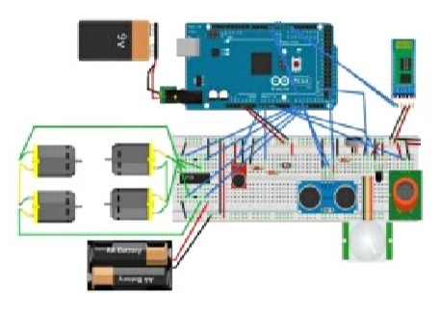 **FIG :4.1 Circuit diagram in Tinker CAD**

Arduino is connected to the 6v battery through a on/off switch. The Bluetooth module is connected to the 3 and 4 pin of the Arduino board. The Ultrasonic sensor is connected to the motor driver and the BO motor are also connected inn the motor driver. The motor driver is directly connected to the power supply of the board.

The ATMega 328P Ic is used in the Arduino micro controller. The PIR sensor is directly connected to the board. The Ultrasonic sensor is placed in the servo motor for rotation and for also setting the path for motion.

**4.2 EXPERIMENTAL RESULT**

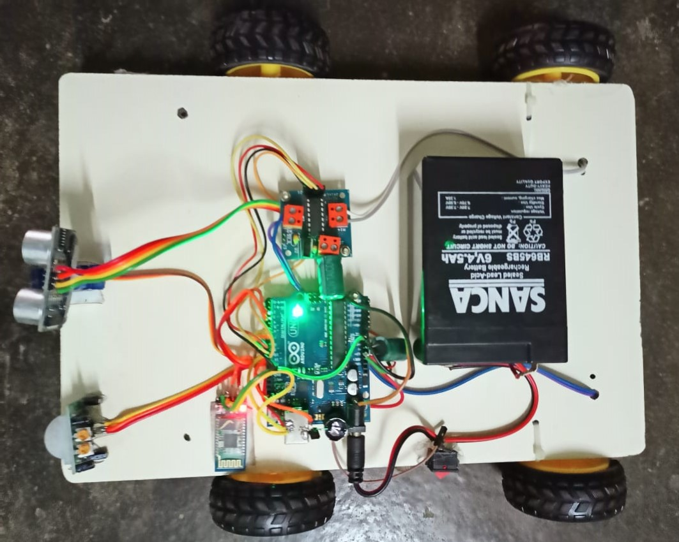

**FIG:4.2 Prototype of the Night patrolling robot**

First turn ON the power switch on the bot, then go to the Arduino remote app and turn on the automatic mode. The bot will start running,, when the ultrasonic sensor a block in the path the servo motor will turn both right and left to find the clear path, then the bot will turn to the path which has a clear path. When it in manual mode using the app we can control the bot easily. The PIR will sense the any human detection using the temperature sensor in-build in it. When there the a detection, it will give a signal to the buzzer to alert the user

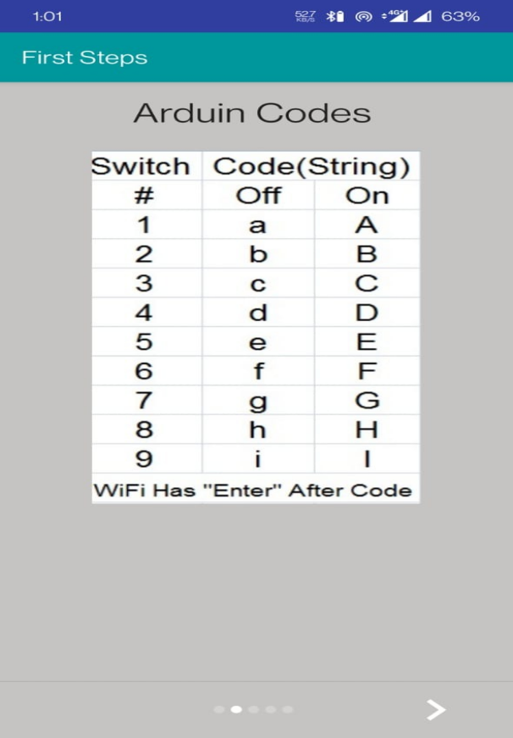

**FIG: 4.3 Remote code**

To operate the bot in manual mode, here we use Arduino remote android app. In the app they assign a character for each button, the code is shown in the above fig:4.3. I have assign the character for the each action like forward, reverse, etc. When we tap the on button in the app it will give a signal to the board through the Bluetooth and that will send the command to the motor.

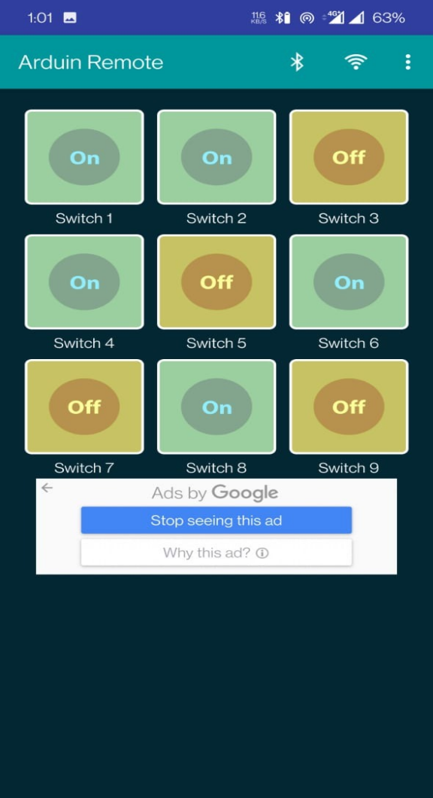

**FIG: 4.4 Arduino remote app**

This is the the application front page. Each ON and OFF button will do a different function. First button will help to turn on the manual mode. The second button will operate as the forward. In the same row the last button will act as reverse. In the second row the both end button will act as left and right action. This is easily operated using the Bluetooth module HC-05. The app will first connected to the bluetooth, then we can whether to use the bot in automatic mode or manual mode

. **CHAPTER 5**

**CONCLUSION**

The entire territory surveillance is finished the night vision camera and furthermore programmed framework when the sound is distinguished robot will follow the specific way and go to that space and catch the region and catch the picture and send it to the user using IOT.Its multisensor feature provides a proficient way to monitor security, avoiding false alarms. A mobile security system is more efficient compared to a fixed security system. The robot features autonomous patrolling in a defined area, however can also be kept stationary. Other than security, the robot can be used for variety of purpose, such as fire alarm, burglar alarm, temperature monitoring, even as a simple alarm clock! Thus the design robot provides a better and safer environment. There is still a wide area of research to be conducted on security robots to fully implement them in our everyday lives.

**5.1 REFERENCES**

[1]. “Mobile Detection Assessment and Response System (MDARS)”, Everett, H. & Gage, D.W, 1999

[2]. “Some 6481 results of the test operation of a security service system with autonomous guard robot”, Y. Shimosasa, J. Kanemoto, K. Hakamada, H. Horii, T. Ariki, Y. Sugawara, F. Kojio, A. Kimura, S. Yuta,2000.

[3]. "Team Mobile Robots Based Intelligent Security System", S. Chia, J. Guo, B. Li and K. Su,, 2013.

[4]. L. Chung, "Remote Teleoperated and Autonomous Mobile Security Robot Development in Ship Environment", Mathematical Problems in Engineering, vol. 2013, Article ID 902013, 2013.

[5].K. Aravind Kumar, G. Praveen Kumar, S. Jayadhar Reddy, R. Manjula. (2020). IOT Based Night Patrolling Robot with Arduino and ESP 32. *International Journal of Advanced Science and Technology*, *29*(04), 4742 -. Retrieved from <http://sersc.org/journals/index.php/IJAST/article/view/24905>

[6]. S. Chavanke and T. Dnyandev Barhate, *WAR FIELD SPYING ROBOT WITH NIGHT VISIONCAMERA*,Feb.2017,[online]Available: <http://data.conferenceworld.in/ICSTM7/39.pdf.>

[7]. P. S. Kumar, V. Vinjamuri, S. G. Priyanka and S. T. Ahamed, "Video Surveillance Robot with Multi Mode Operation", *International Journal of Engineering Research & Technology*, vol. 5, no. 2, Feb. 2016, [online] Available:

[8]. P. Manasa, K. Sri Harsha, D. D M, K. R and N. Nichal O, "NIGHT VISION PATROLLING ROBOT", *Journal of Xi’an University of Architecture & Technology*, vol. 8, no. 5, Apr. 2020, [online] Available: http://xajzkjdx.cn/gallery/18-may2020.pdf?fbclid=IwAR1eIb3WB9dCoM0A7U7kZOP5j8hMckye9DPVR2G_BnpvIVWpva0svMMVqg4

[9]. Real-time Object Detection And Tracking On Moving Camera Platform-IEEE Conference Publication(2009,August1).IEEE Journals & Magazine

[10]. WOMEN SAFETY NIGHT PATROLLING ROBOT USING IOT BY Babu M Renu, Krishna B Hari, Rakesh G, Tejashri M Sai, Parichitha Y, International Journal of Engineering and Management Research Year:2021, Volume : 11, Issue: 3